Assignment-1:-

1.get all documents





2.get all documents with writer set to "Quentin Tarantino"

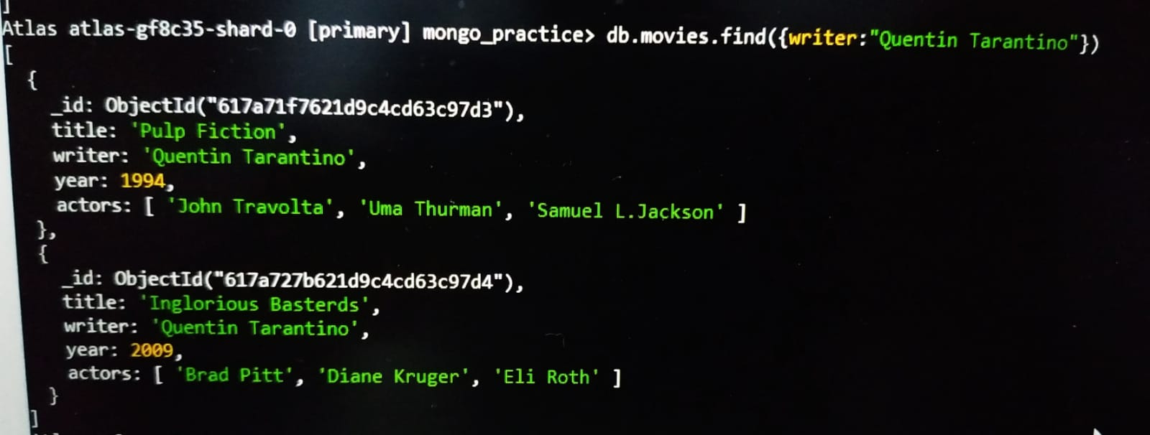

3.get all documents where actors include "Brad Pitt"



4.get all documents with franchise set to "The Hobbit"



5.get all movies released in the 90s

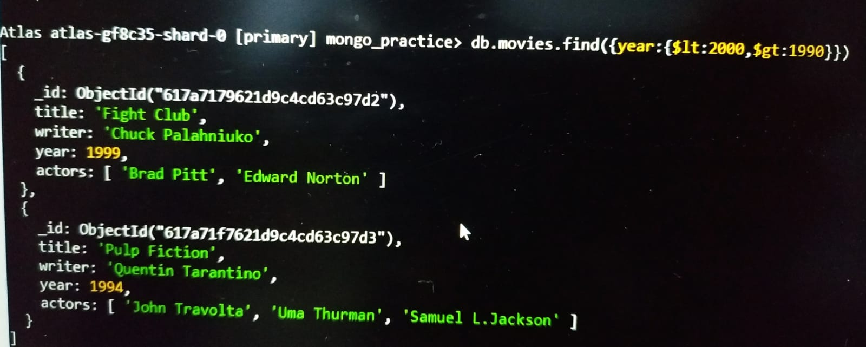

6.get all movies released before the year 2000 or after 2010

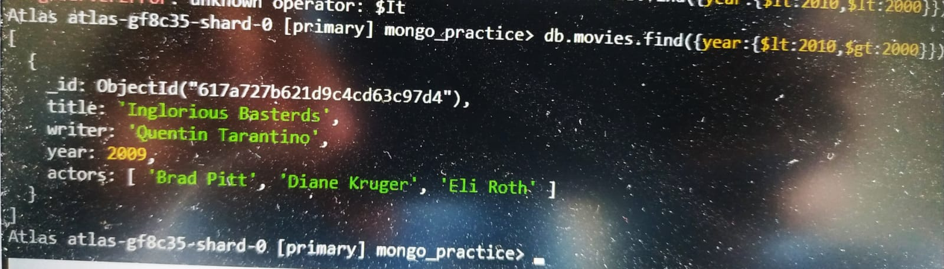

**Text Search**

1.find all movies that have a synopsis that contains the word "Bilbo"



2.find all movies that have a synopsis that contains the word "Gandalf"



3.find all movies that have a synopsis that contains the word "Bilbo" and not the word "Gandalf"

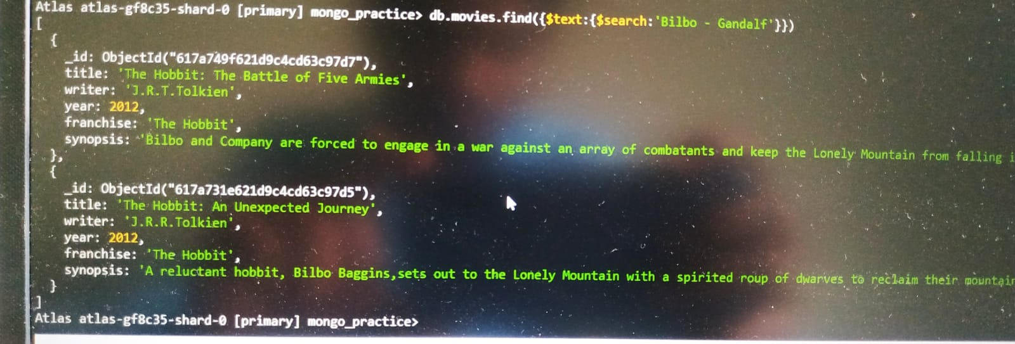

4.find all movies that have a synopsis that contains the word "dwarves" or "hobbit"

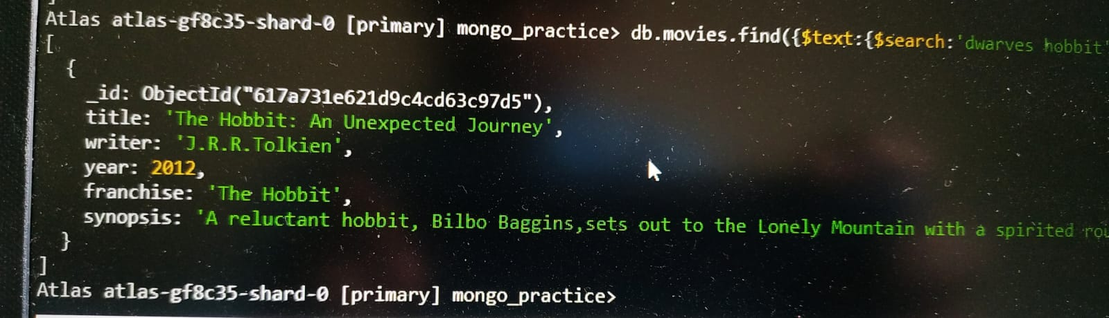

5.find all movies that have a synopsis that contains the word "gold" and "dragon"

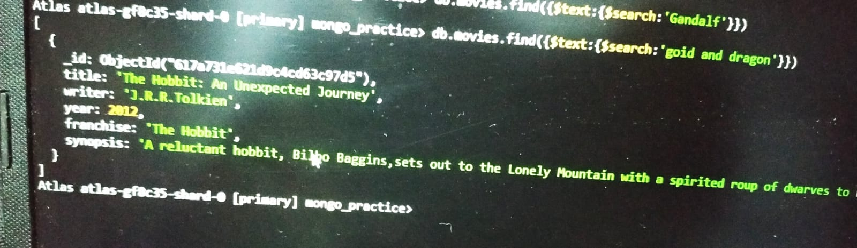

1.find all users



2.find all posts



3.find all posts that was authored by "GoodGuyGreg"



4.find all posts that was authored by "ScumbagSteve"



5.find all comments



6.find all comments that was authored by "GoodGuyGreg"



7.find all comments that was authored by "ScumbagSteve"



Assignment:-2

**MongoDB -Aggregation Exercises**

**Atlanta Population**

1. use db.zipcodes.find() to filter results to only the results where city is ATLANTA and state is GA.





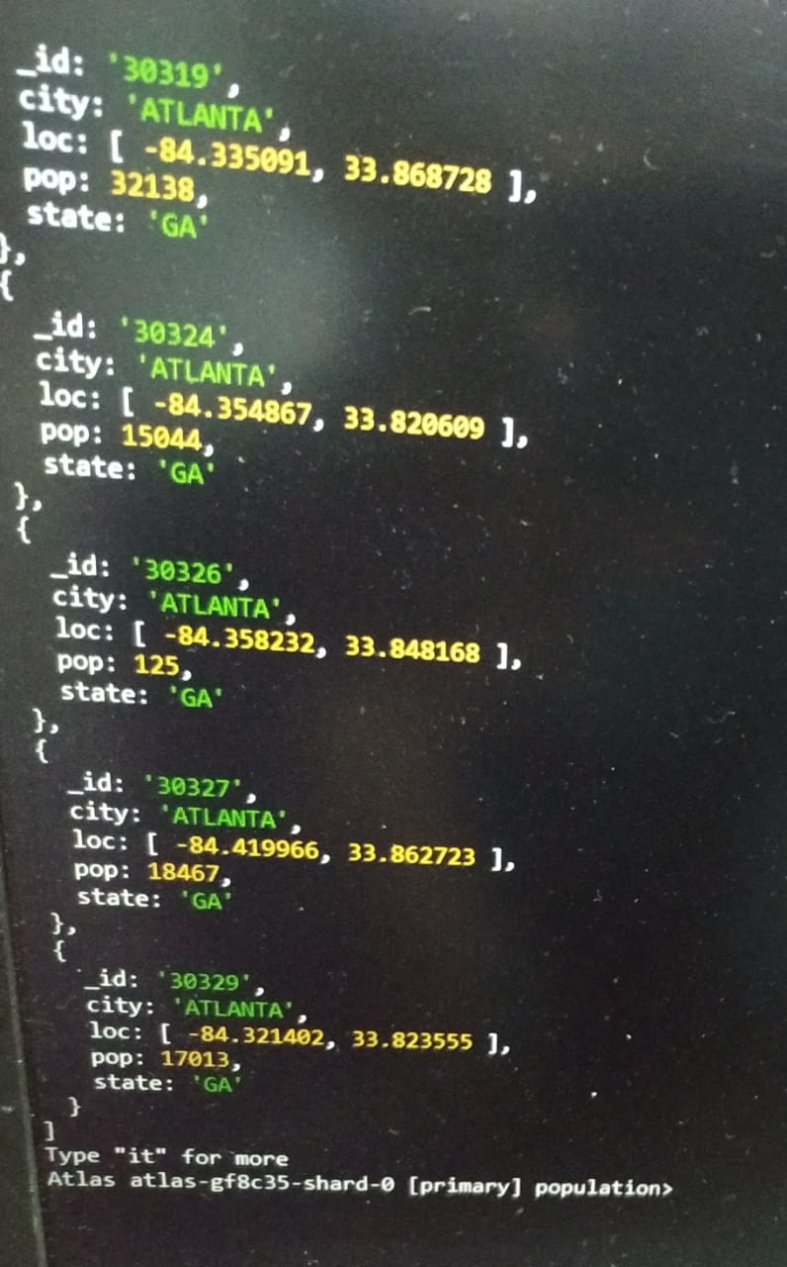

2.use db.zipcodes.aggregate with $match to do the same as above



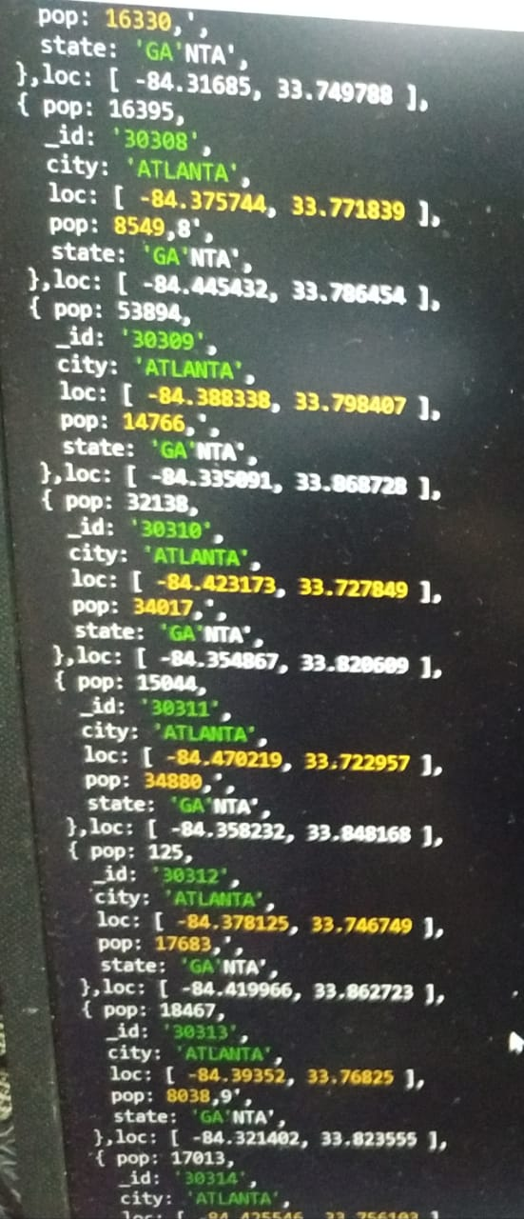

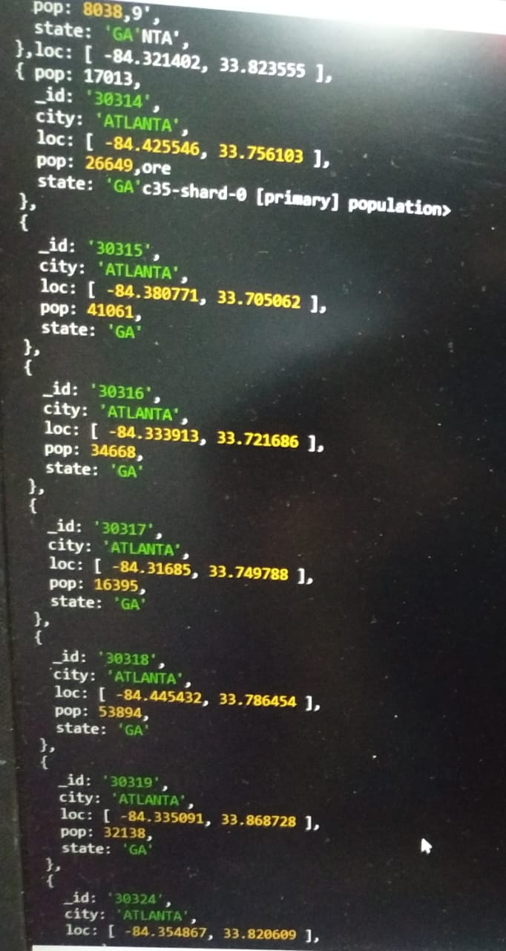

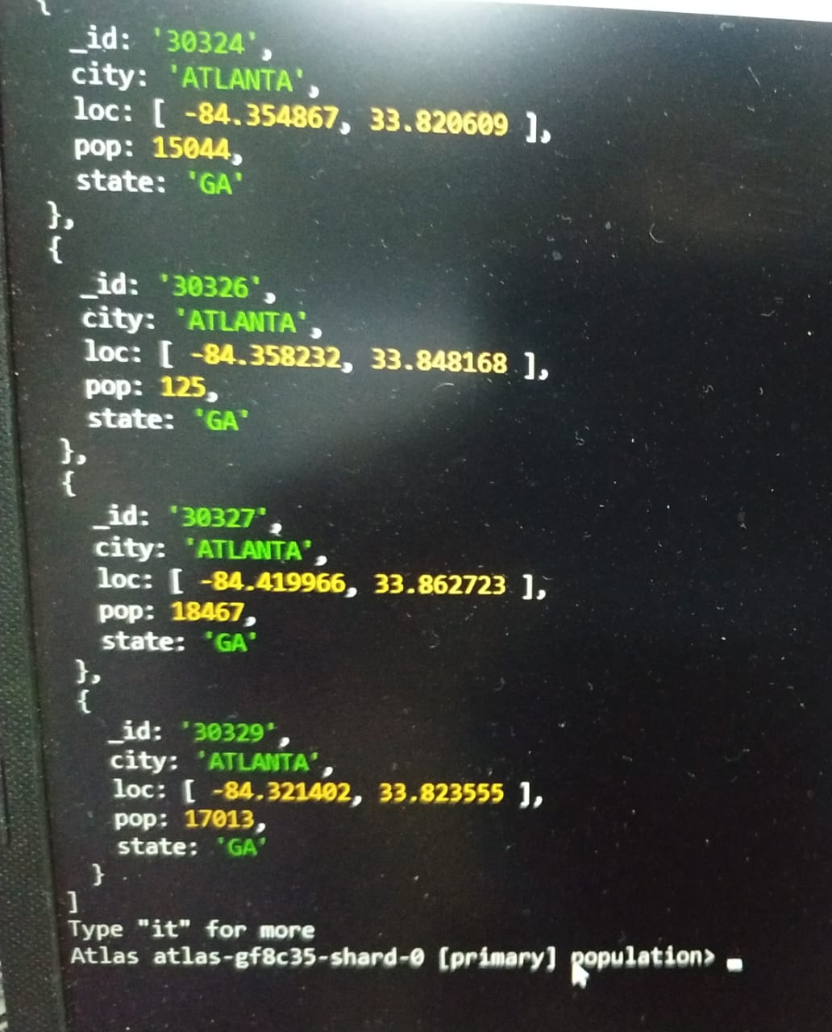

3.use $group to count the number of zip codes in Atlanta.



4.use $group to find the total population in Atlanta

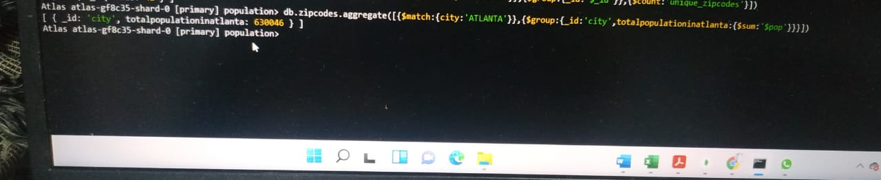

**Populations By State**

1.use aggregate to calculate the total population for each stat

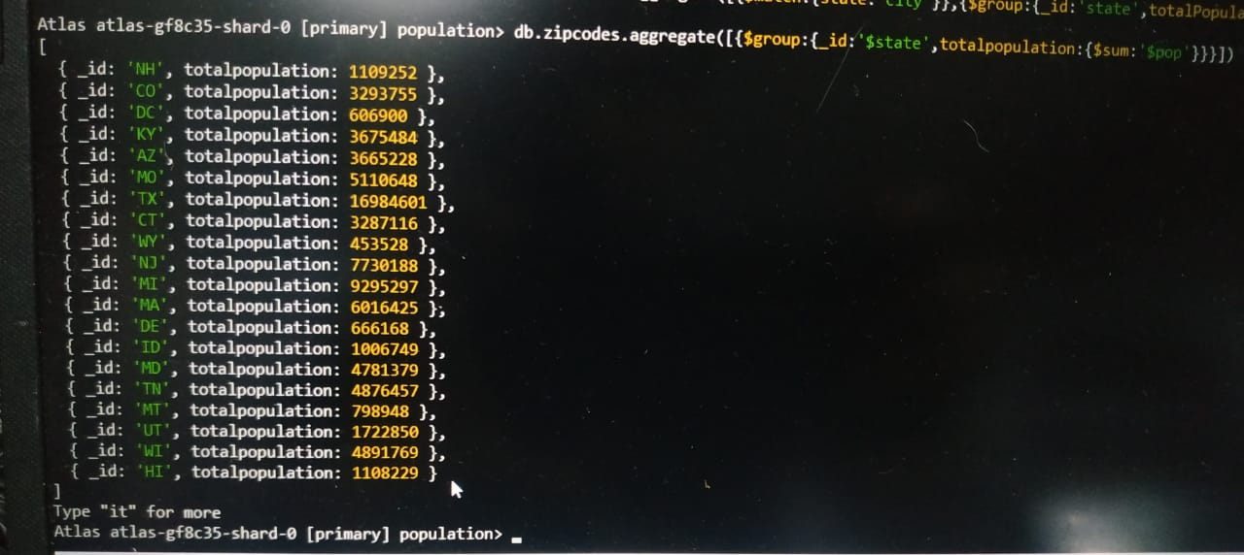

2.sort the results by population, highest first

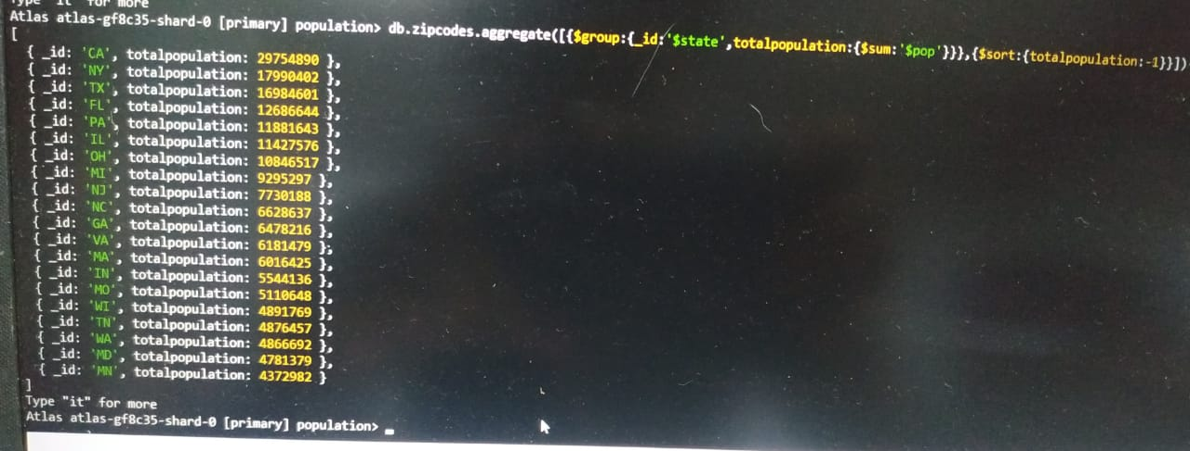

3.limit the results to just the first 3 results. What are the top 3 states in population?

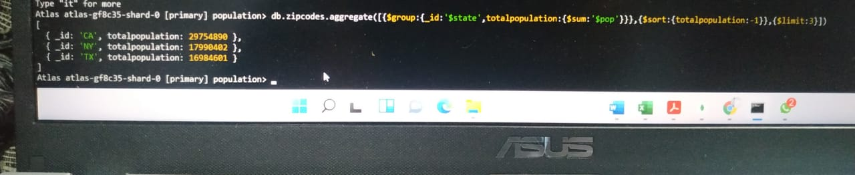

**Populations by City**

1.use aggregate to calculate the total population for each city (you have to use city/state combination). You can use a combination for the _id of the $group: { city: '$city', state: '$state' }

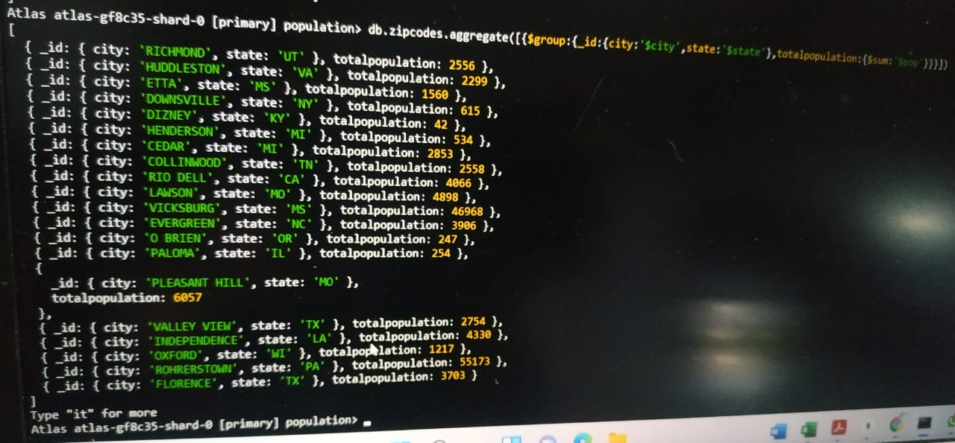

2.sort the results by population, highest first



3.limit the results to just the first 3 results. What are the top 3 cities in population?

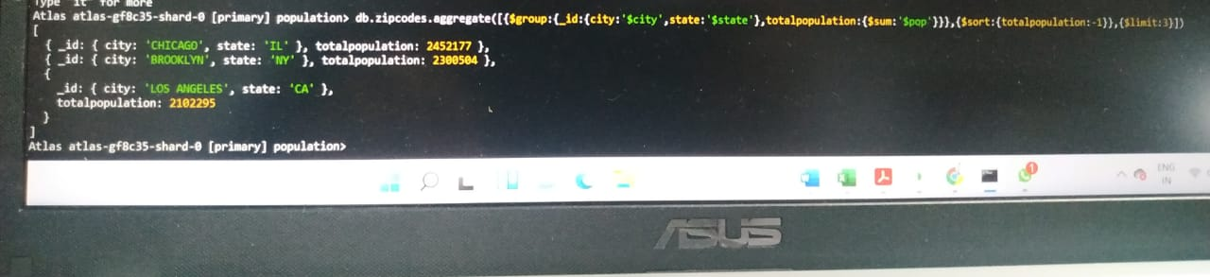

4.What are the top 3 cities in population in Texas?

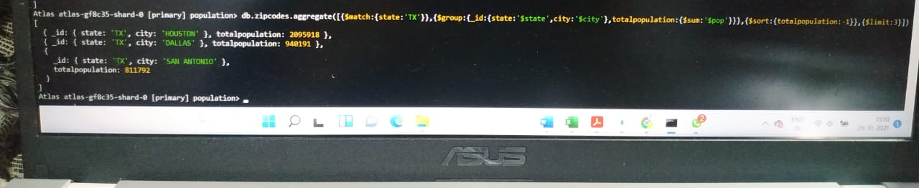

**Bonus**

**1.**Write a query to get the average city population for each state

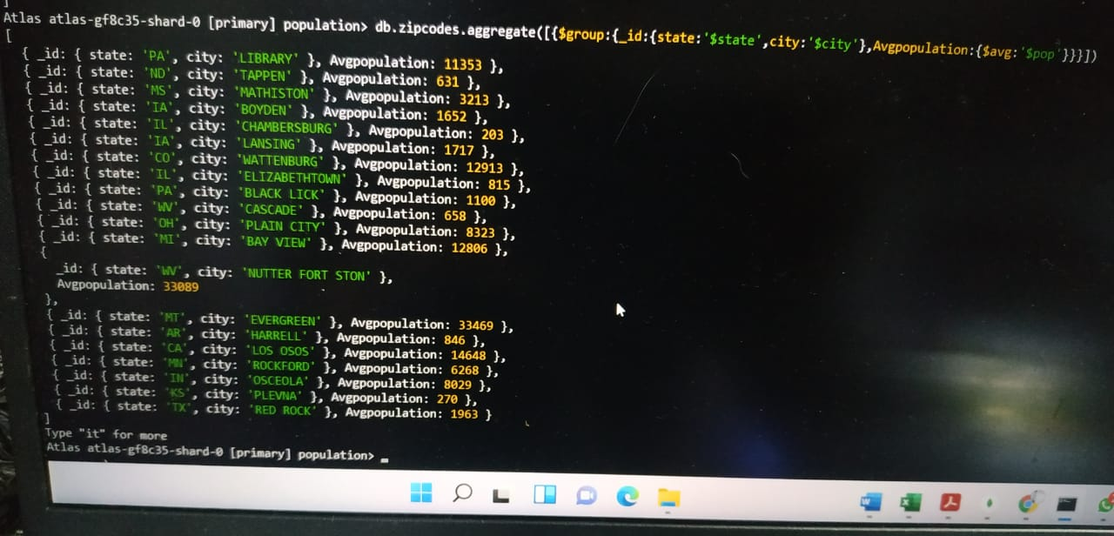

2.What are the top 3 states in terms of average city population?

